# Question Set 02

### Boiling

1. -
2. -
3. The properties of water at the saturation temperature of 100°C are σ = 0.0589 N/m (Table 10-1). Water properties are:  
   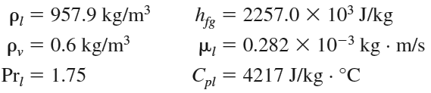  
   Also, Csf = 0.0130 and n=1.0 for the boiling of water on a mechanically polished stainless steel surface (Table 10–3). Note that we expressed the properties in units specified under Eq. 10–2 in connection with their definitions in order to avoid unit manipulations.

(a) The excess temperature in this case is ΔT = Ts -Tsat = 108 – 100 = 8oC. Therefore, nucleate

boiling will occur. The heat flux is determined from the Rohsenow relation

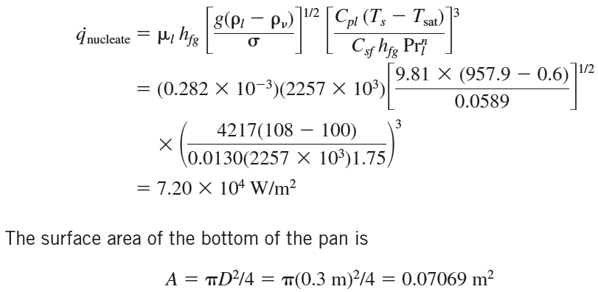

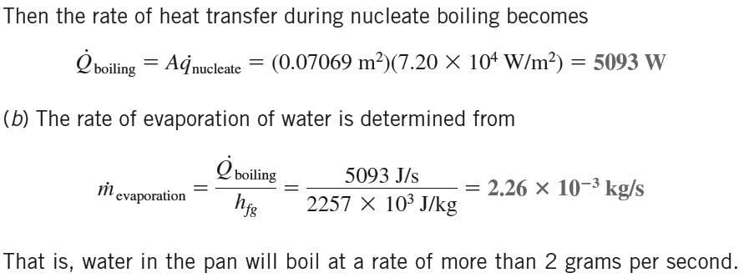

1. 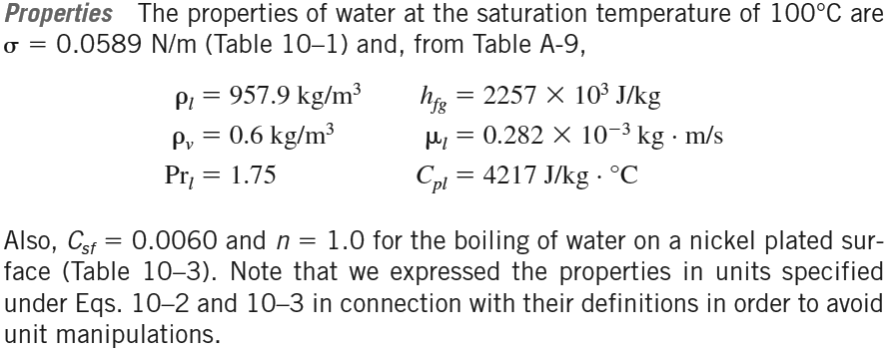

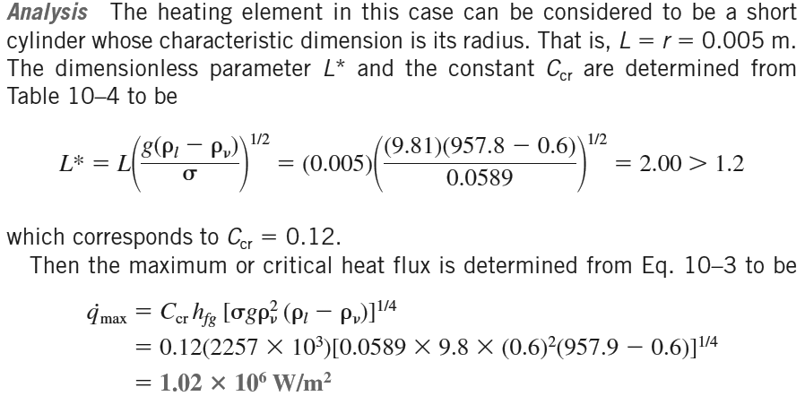

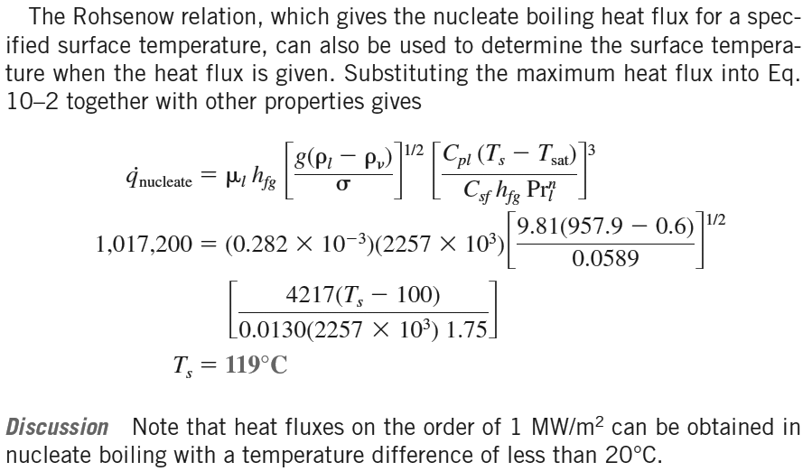

1. 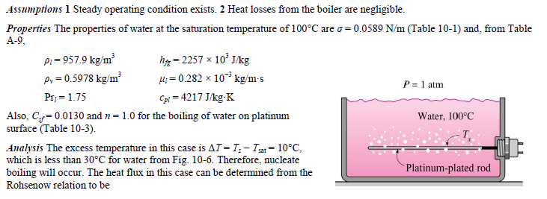

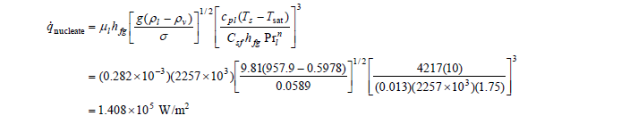

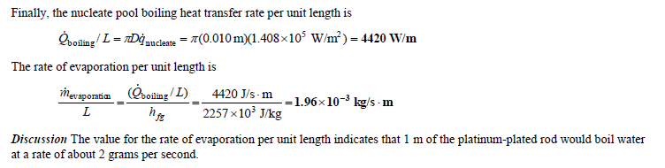

1. 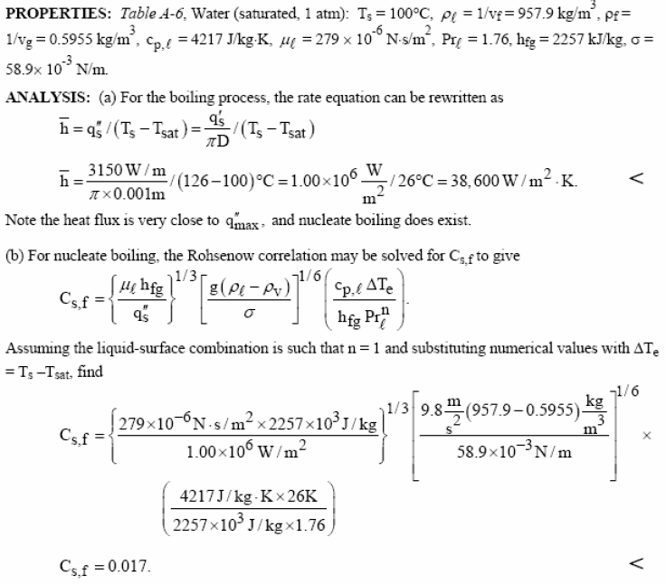

Other Cs,f value is comparatively large suggesting that its surface must be highly polished to achieve the same h value.

1. 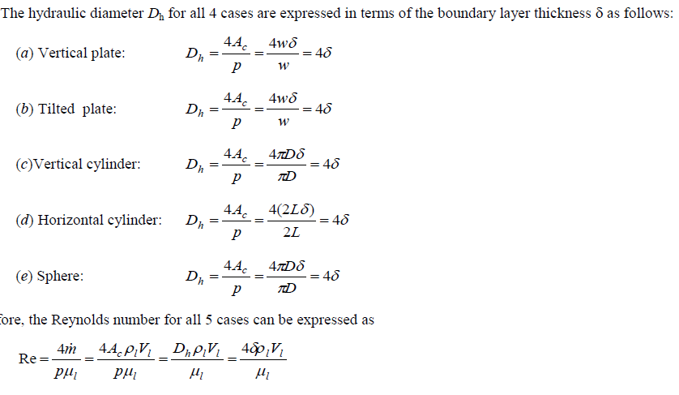

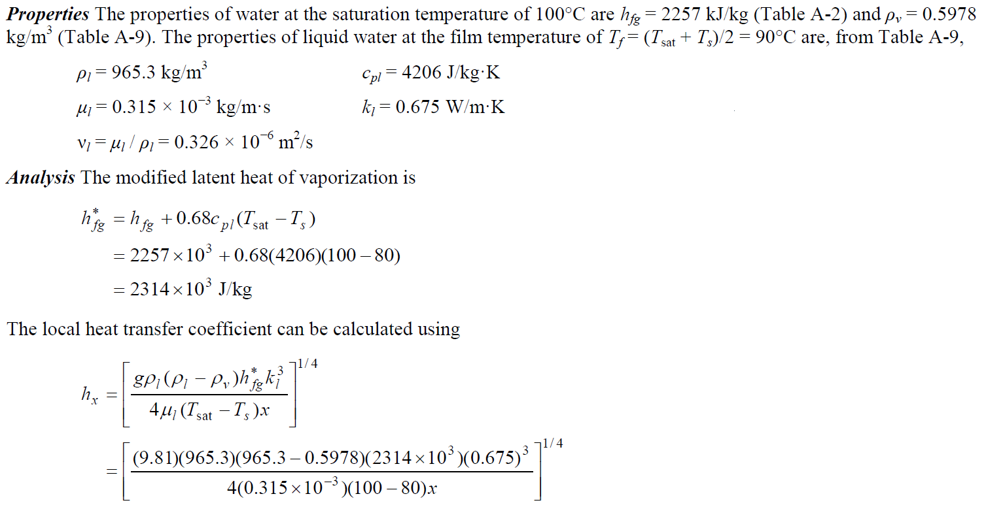

*\*Note that this is the local heat transfer coefficient, and there is a 4 in the denominator. In class we calculated the average overall heat transfer at length x=0.1m and x=0.2m. The 4 in the denominator drops out for the average value.*

